Date: 2023/09/30

From: 11204604 洪哲文

Assignment:

Slide25:

Measuring the Central Tendency-Example

The values for salary (in thousands of dollars), shown in increasing order: 30, 36, 47, 50, 52, 52, 56, 60, 63, 70, 70, 110

Mean salary= (30+36+47+50+52+52+56+60+63+70+70+110)/12 = 58

Median = (52+56)/2 = 54

Mode = 52, 70

Slide31:

Example of boxplot

The math scores of 12 students:

59, 60, 64, 65, 67, 70, 72, 74, 75, 76, 78, 80

1) Please show the five number summary:

Min= 59

Q1= (64+65)/2= 64.5

Median= (70+72)/2= 71

Q3= (75+76)/2= 75.5

Max= 80

IQR= (75.5-64.5)=11

2) Draw a boxplot

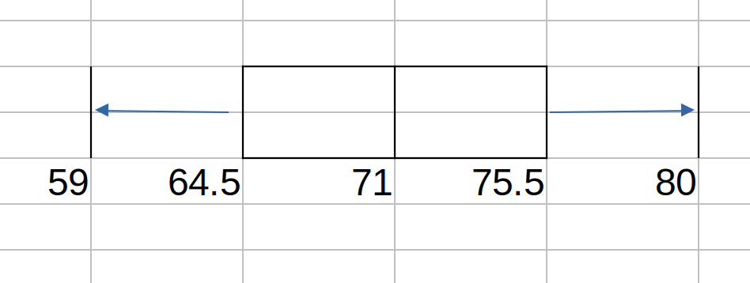

Lower Bound = 64.5(Q1) - 1.5x11(IRQ) = 48

Upper Bound = 75.5(Q3) + 1.5x11(IRQ) = 92

Any number less than 48 or greater than 92 is considered an outlier.

In this dataset, we have no such outliers.

***Question:***

***Is the ‘Whiskers’ means the Lower and Upper Bound?***